Fermi Energy in Density of States Calculation for LaPO₄
K-point | E_{Fermi} (SCF) | E_{Fermi} (SCF) | E_{Fermi} (DOS) used in plotting the graph
10 | 12.8279 | 7.1779 | 7.1779
12 | 12.8279 | 12.9084 | 7.1779
14 | 12.8279 | 12.9084 | 7.1779
16 | 12.8279 | 7.1779 | 7.1779
18 | 12.8279 | 7.1778 | 7.1779

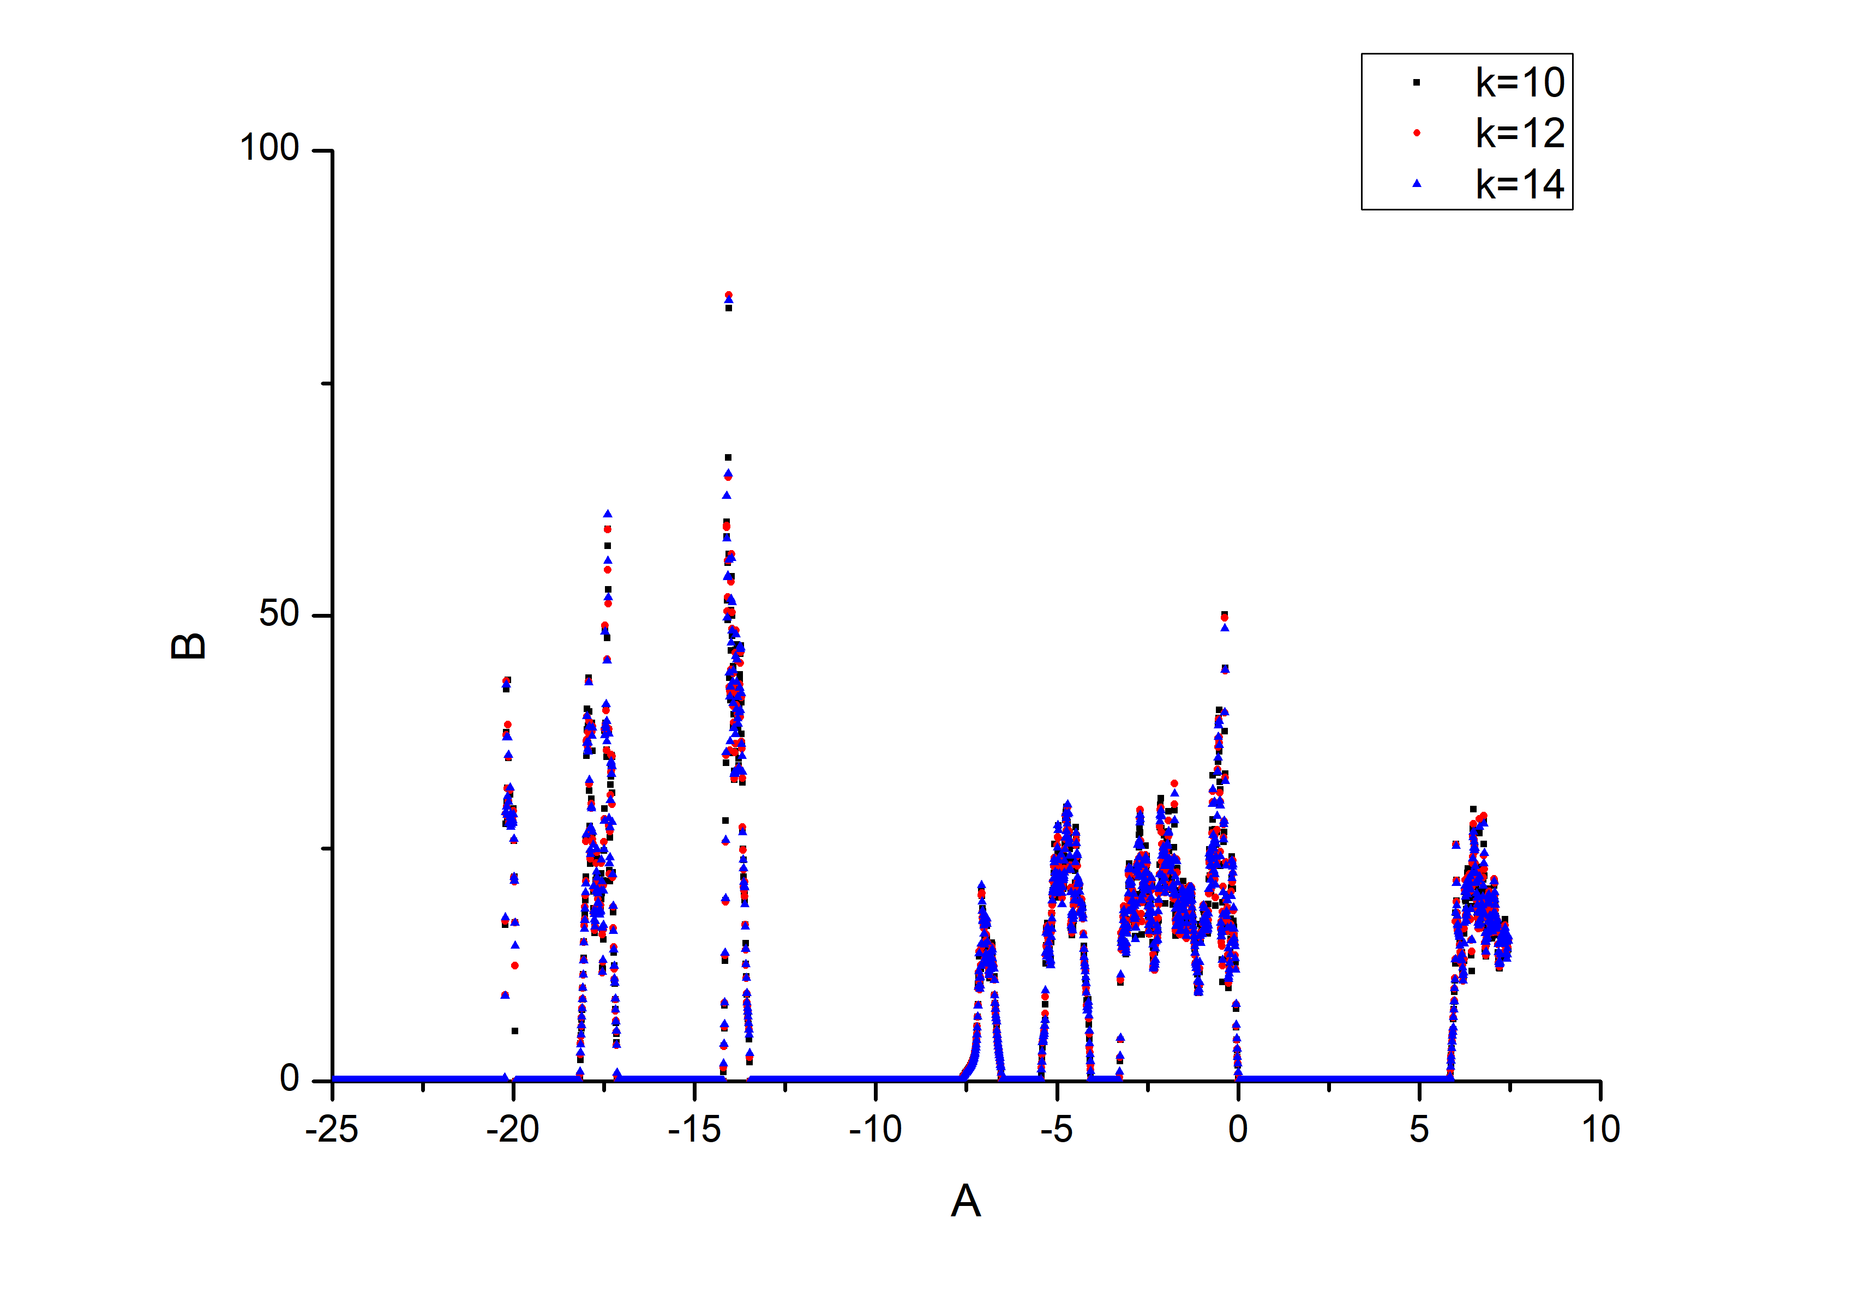

SCF Input
&control
calculation = 'scf'
restart_mode='from_scratch',
prefix='LaPO4',
pseudo_dir ='/home2/yogesh/Mywork/PhD/LaPO4/Pure/pbepaw/',
outdir='/home2/yogesh/Mywork/PhD/LaPO4/Pure/pbepaw/ambient/dos/outdir',
/
&SYSTEM
ibrav= 0,
celldm(1) = 13.0,
nat = 24,
ntyp = 3,
ecutwfc = 80 ,
ecutrho = 400 ,
occupations = 'smearing' ,
degauss = 0.05 ,
smearing = 'methfessel-paxton' ,
/
&ELECTRONS
conv_thr = 1D-8 ,
mixing_mode = 'TF' ,
mixing_beta = 0.7 ,
/
CELL_PARAMETERS alat
1.0063000 0.000000000 0.001154019
0.000000000 1.037206297 0.000000000
-0.224024481 0.000000000 0.924622174
ATOMIC_SPECIES
La 138.90000 La.pbe-n-bpaw.UPF
P 30.97300 P.pbe-n-kjpaw_psl.0.1.upf
O 15.99900 O.pbe-n-kjpaw_psl.0.1.upf
ATOMIC_POSITIONS crystal
La 0.284590303 0.157248128 0.097447480
La 0.715409727 0.842751858 0.902552497
La 0.215409697 0.657248142 0.402552527
La 0.784590273 0.342751858 0.597447503
P 0.303366323 0.161549460 0.611278232
P 0.696633647 0.838450525 0.388721768
P 0.196633677 0.661549475 0.888721768
P 0.803366353 0.338450525 0.111278232
O 0.250071384 0.006421307 0.441770872
O 0.749928616 0.993578667 0.558229098
O 0.249928616 0.506421333 0.058229128
O 0.750071384 0.493578697 0.941770902
O 0.381031881 0.329917127 0.499694968
O 0.618968148 0.670082873 0.500305032
O 0.118968119 0.829917127 0.000305032
O 0.881031852 0.170082873 0.999694968
O 0.469674074 0.103432586 0.804875915
O 0.530325926 0.896567406 0.195124085
O 0.030325926 0.603432594 0.695124085
O 0.969674074 0.396567406 0.304875915
O 0.126892375 0.211812137 0.708352777
O 0.873107655 0.788187893 0.291647223
O 0.373107625 0.711812107 0.791647223
O 0.626892345 0.288187863 0.208352777

K_POINTS automatic
10 10 10 0 0 0

NSCF Input
&control
calculation = 'nscf'
restart_mode='from_scratch',
prefix='LaPO4',
pseudo_dir ='/home2/yogesh/Mywork/PhD/LaPO4/Pure/pbpaw/',
outdir='/home2/yogesh/Mywork/PhD/LaPO4/Pure/pbepaw/ambient/dos/outdir/',
/
&SYSTEM
ibrav= 0,
celldm(1) = 13.0,
nat = 24,
ntyp = 3,
ecutwfc = 80 ,
ecutrho = 400 ,
occupations = 'tetrahedra' ,
degauss = 0.05 ,
smearing = 'methfessel-paxton' ,
/
&ELECTRONS
conv_thr = 1D-8 ,
mixing_mode = 'TF' ,
mixing_beta = 0.7 ,
/
CELL_PARAMETERS alat
1.0063000 0.000000000 0.001154019
0.000000000 1.037206297 0.000000000
-0.224024481 0.000000000 0.924622174
ATOMIC_SPECIES
La 138.90000 La.pbe-n-bpaw.UPF
P 30.97300 P.pbe-n-kjpaw_psl.0.1.upf
O 15.99900 O.pbe-n-kjpaw_psl.0.1.upf
ATOMIC_POSITIONS crystal
La 0.284590303 0.157248128 0.097447480
La 0.715409727 0.842751858 0.902552497
La 0.215409697 0.657248142 0.402552527
La 0.784590273 0.342751858 0.597447503
P 0.303366323 0.161549460 0.611278232
P 0.696633647 0.838450525 0.388721768
P 0.196633677 0.661549475 0.888721768
P 0.803366353 0.338450525 0.111278232
O 0.250071384 0.006421307 0.441770872
O 0.749928616 0.993578667 0.558229098
O 0.249928616 0.506421333 0.058229128
O 0.750071384 0.493578697 0.941770902
O 0.381031881 0.329917127 0.499694968
O 0.618968148 0.670082873 0.500305032
O 0.118968119 0.829917127 0.000305032
O 0.881031852 0.170082873 0.999694968
O 0.469674074 0.103432586 0.804875915
O 0.530325926 0.896567406 0.195124085
O 0.030325926 0.603432594 0.695124085
O 0.969674074 0.396567406 0.304875915
O 0.126892375 0.211812137 0.708352777
O 0.873107655 0.788187893 0.291647223
O 0.373107625 0.711812107 0.791647223
O 0.626892345 0.288187863 0.208352777

K_POINTS automatic
10 10 10 0 0 0

DOS Input
&DOS
prefix = 'LaPO4' ,
outdir = '/home2/yogesh/Mywork/PhD/LaPO4/Pure/pbepaw/ambient/dos/outdir/' ,
fildos = 'LaPO4.dos-0.01.dat' ,
DeltaE = 0.01 ,
/

